***HOSTING A DYNAMIC WEBSITE USING EC2 INSTANCE***

First create a .sql file so we can just directly import all the databases.

Go to localhost-> click the database that i need to export-> click on export

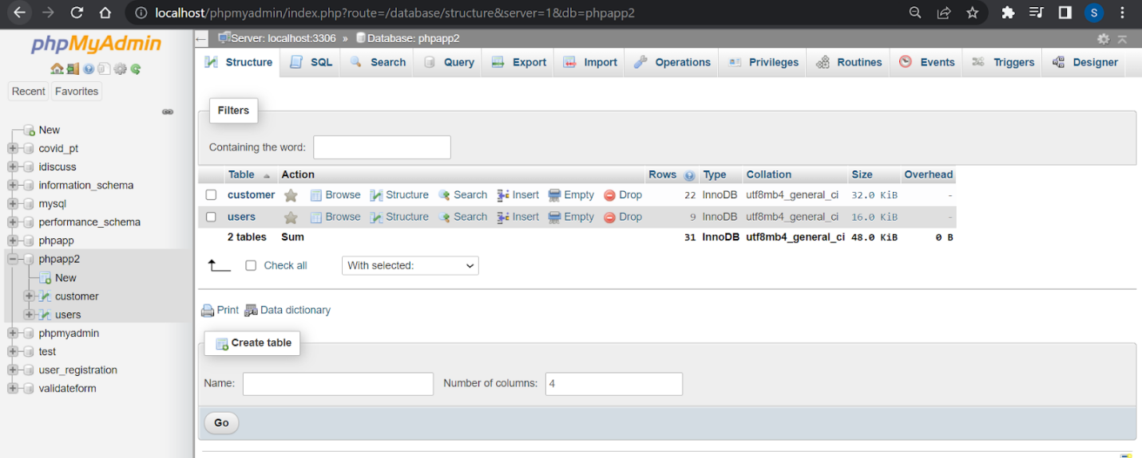

Select the tables  and then click on Go

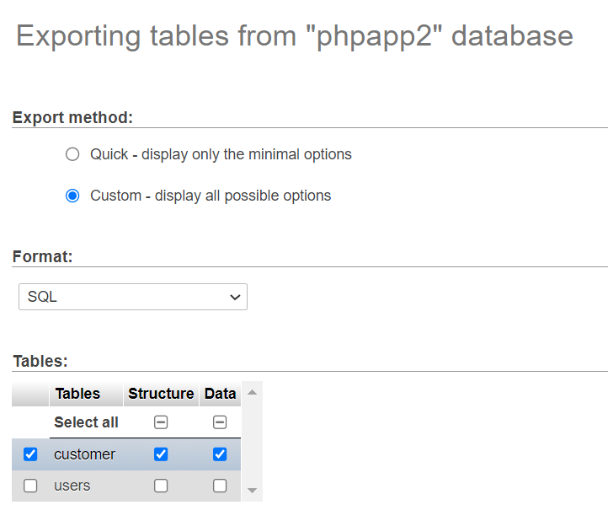

Save the file with the project files itself, in the htdoc folder

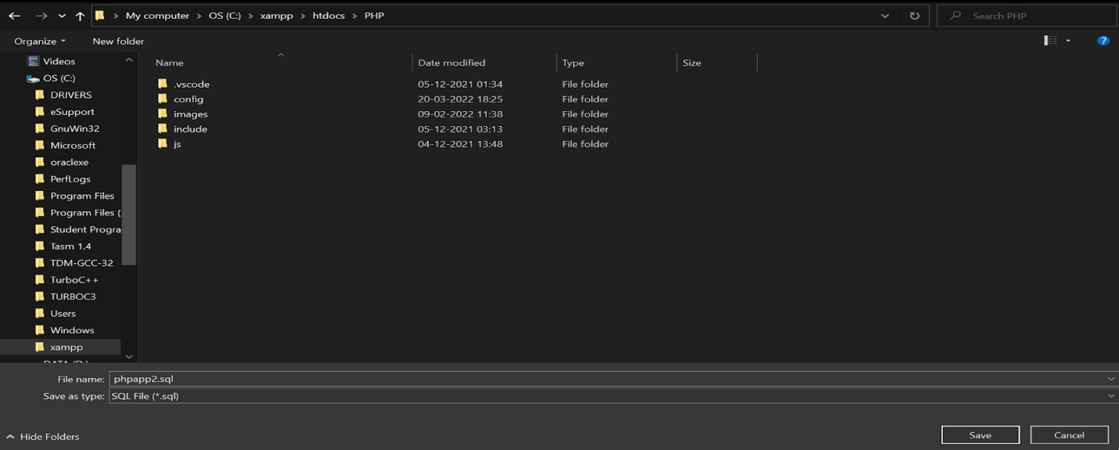

—----------------------------------------------------------------------------------------------------------

Now sign in to your aws management console account.

Search for ec2

Open instances(running)

Now launch a new instance

Select an ami

We’ve chosen a free tier windows ami.

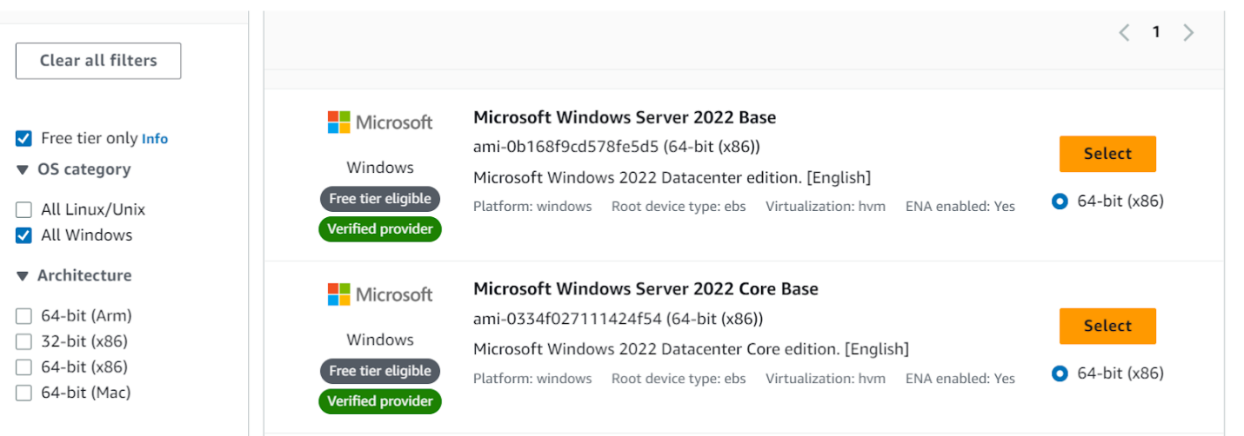

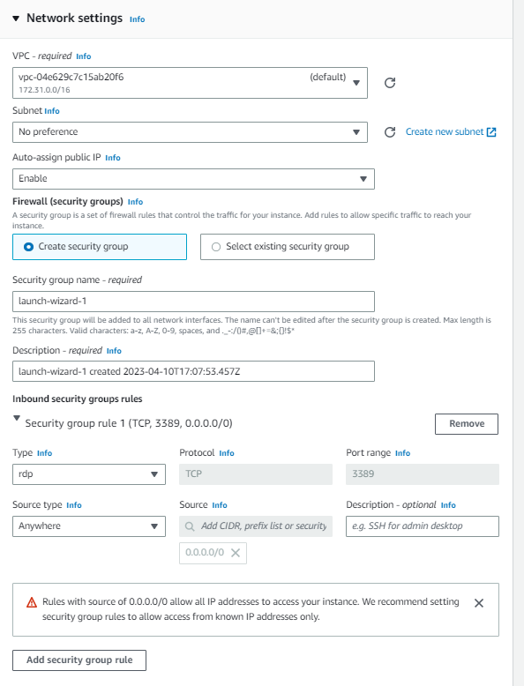

Add a new security group rule

Newly added : http & https

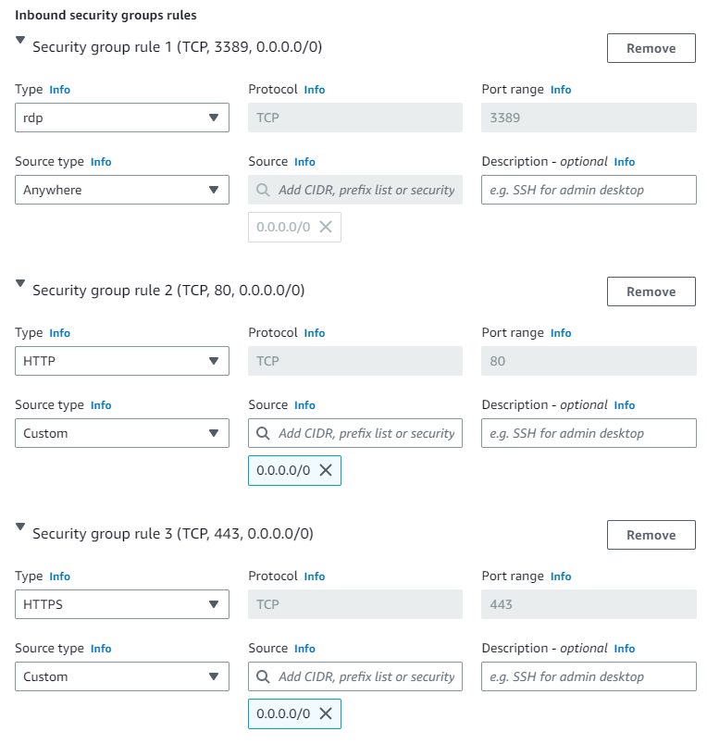

Now create a new key pair

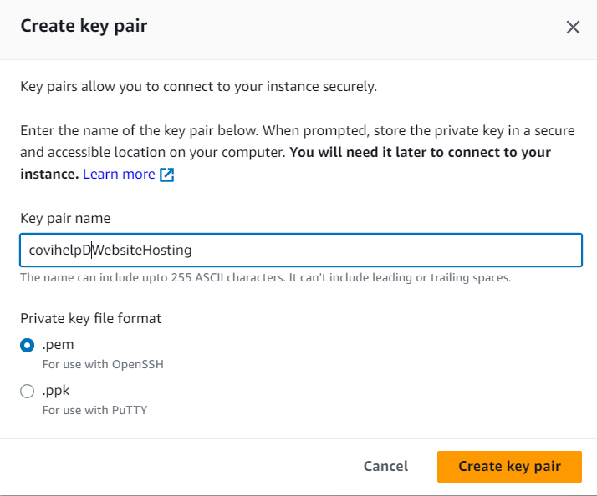

Now launch the instance

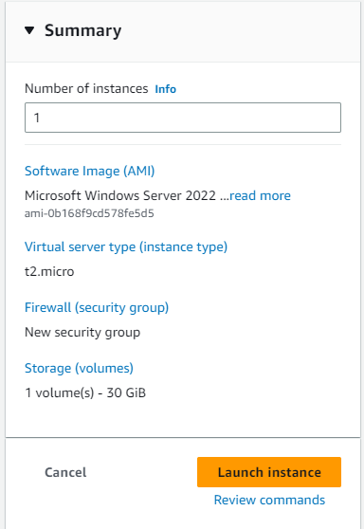

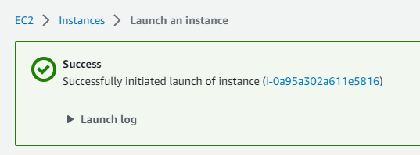

Launched successfully

Wait until it shows 2/2 checks passed in status.

Now select that instance and click on connect

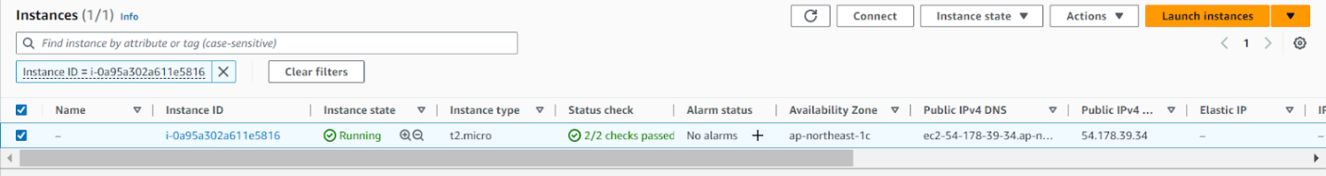

Go to rdp client here

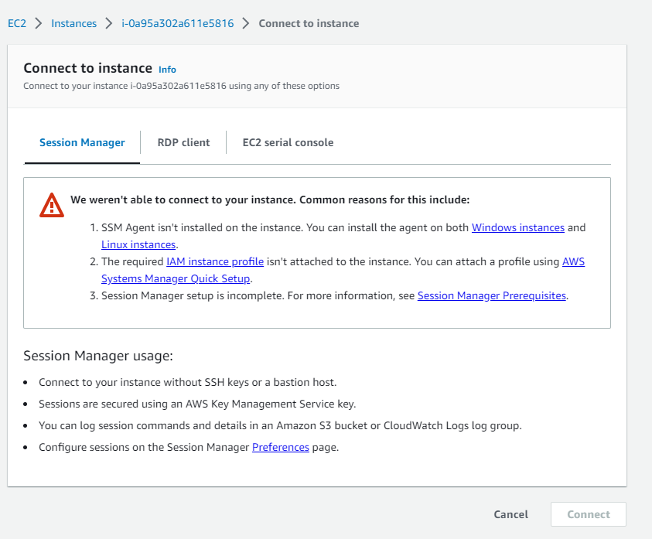

Click on download remote desktop file here

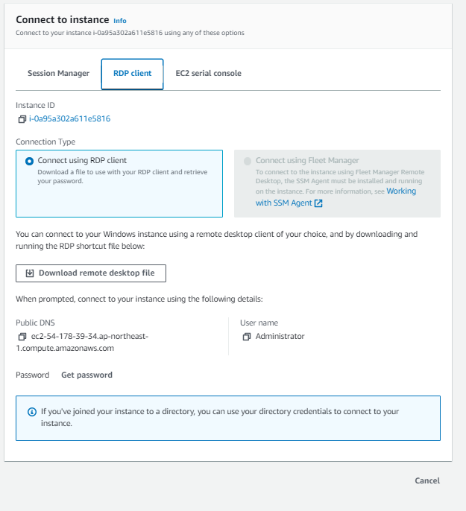

After it is downloaded, click on get password and browse your key pair.

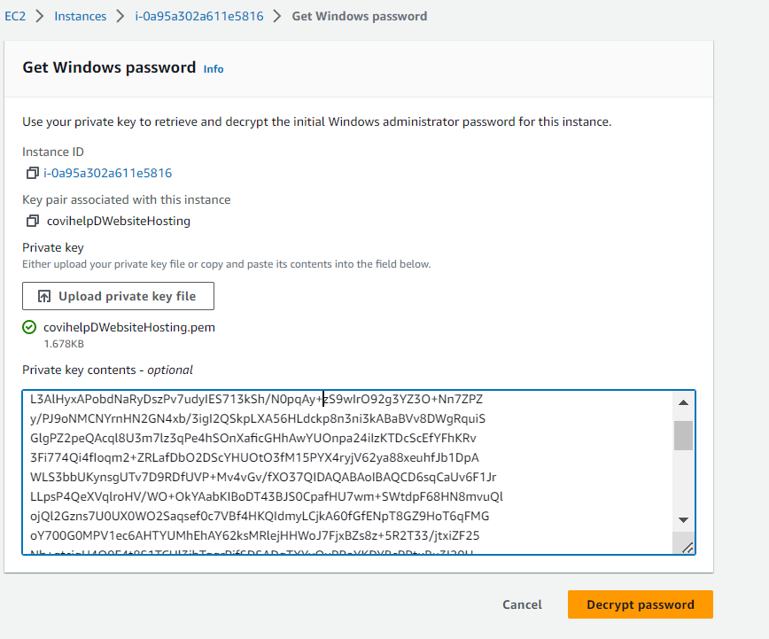

Click on decrypt password

Done.

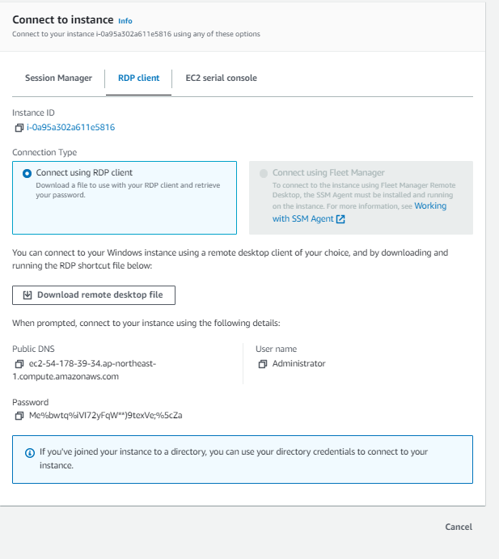

Now go to start-> remote desktop connection

Now copy the public dns :  ec2-54-178-39-34.ap-northeast-1.compute.amazonaws.com

And click on connect

Copy the pswd : Me%bwtq%iVI72yFqW**)9texVe;%5cZa

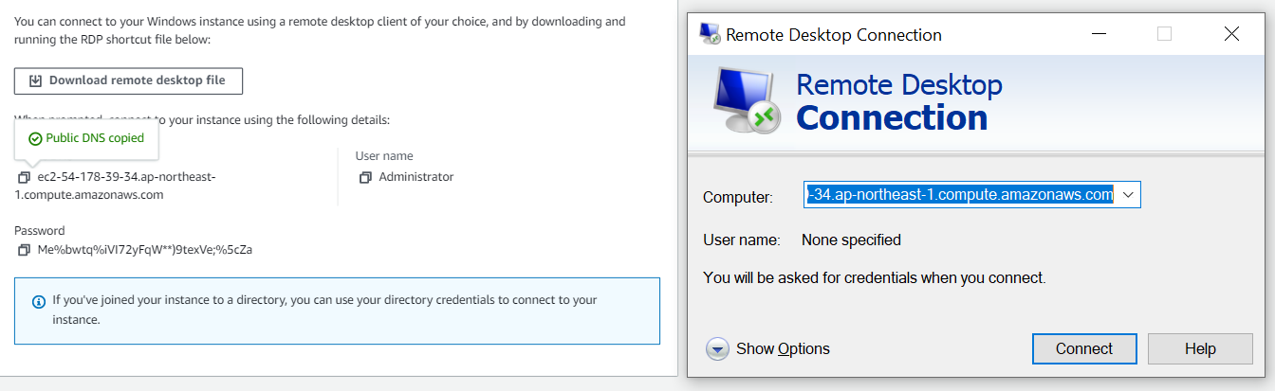

Click on more choices below

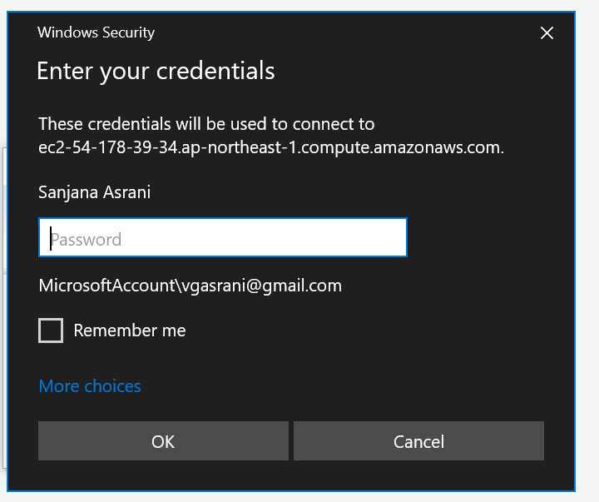

Use a different account

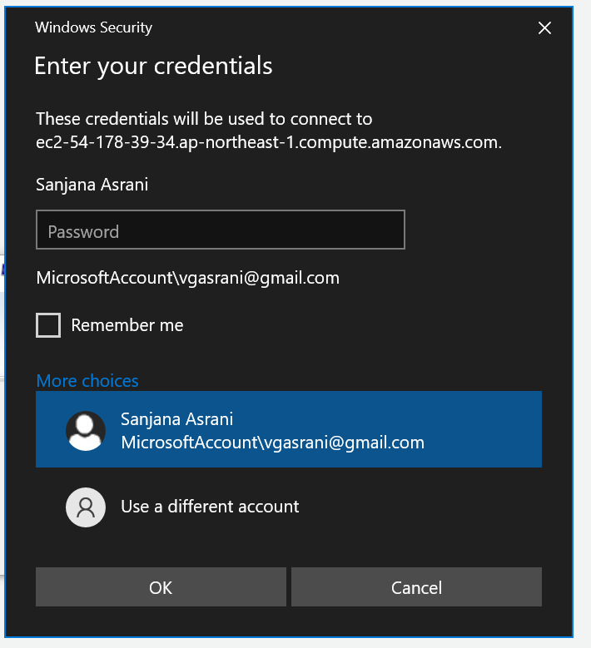

Now put username as Administrator and copy paste the password decrypted.

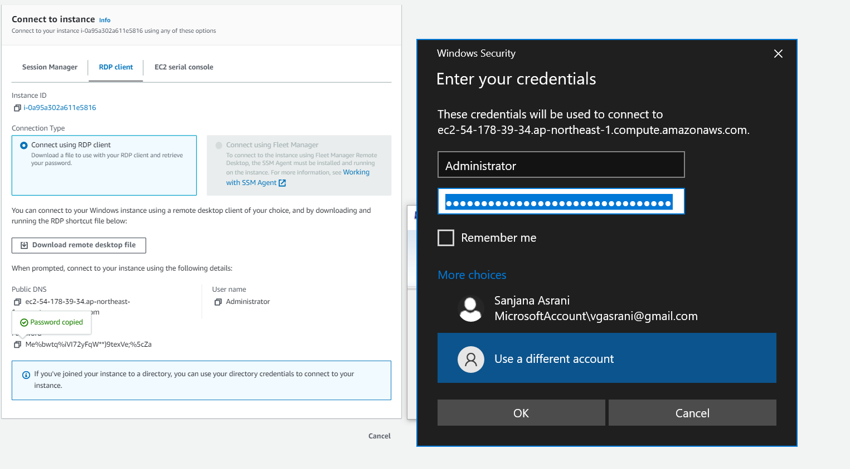

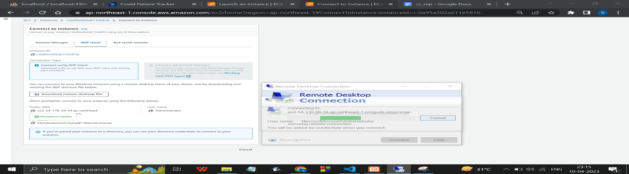

The following prompt will open up

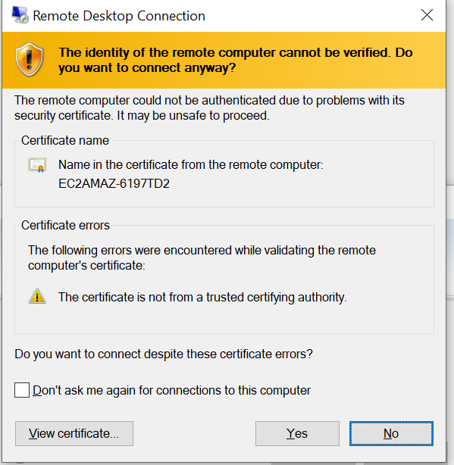

Click on yes.

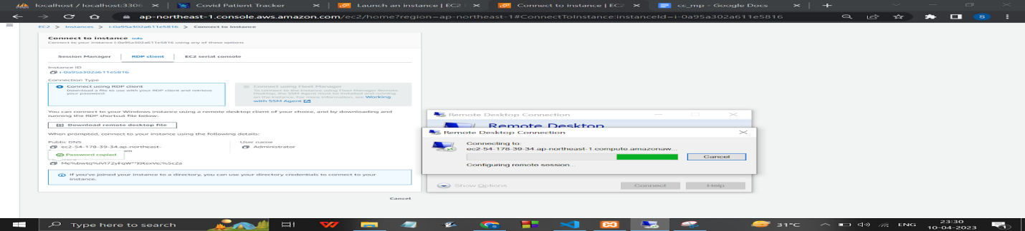

……………………………. Inside the ec2 instance ………………..

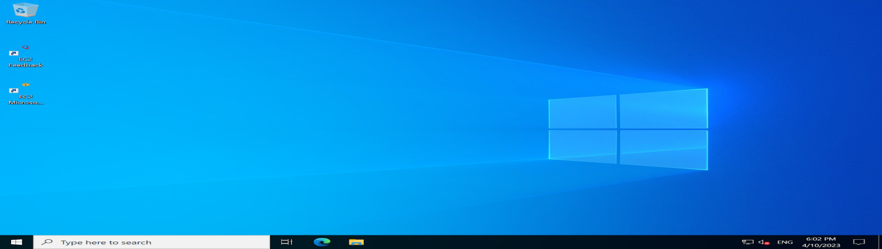

Now go to start-> windows security-> firewall & network protection-> advanced settings

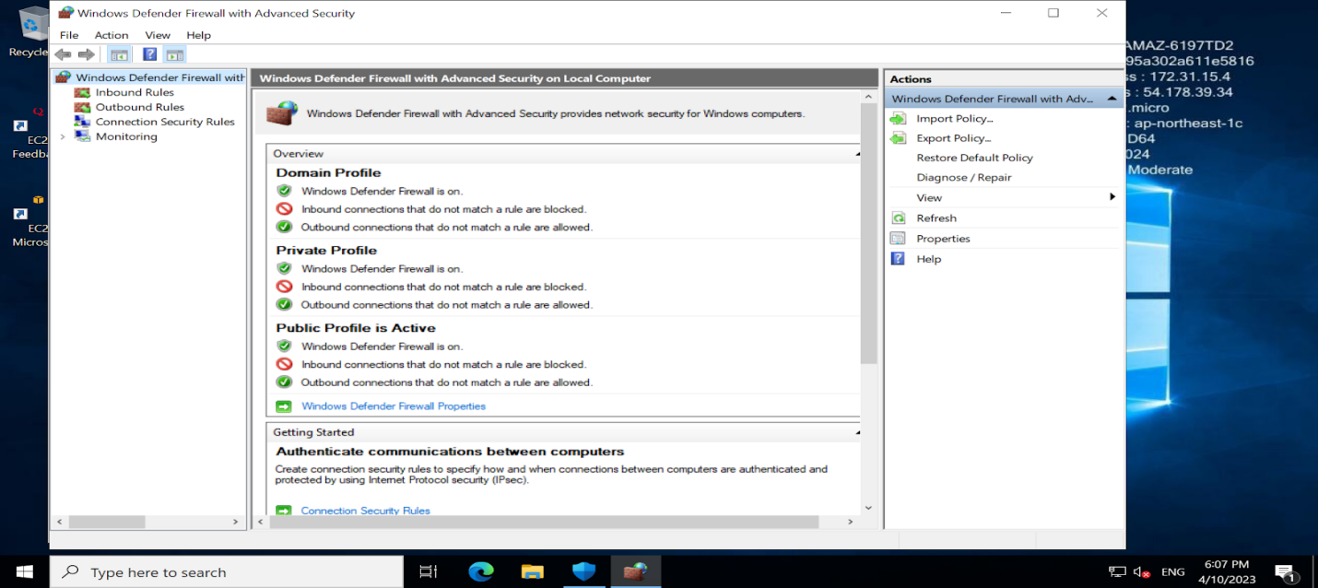

Go to windows defender firewall properties-> public profile -> allow inbound connections

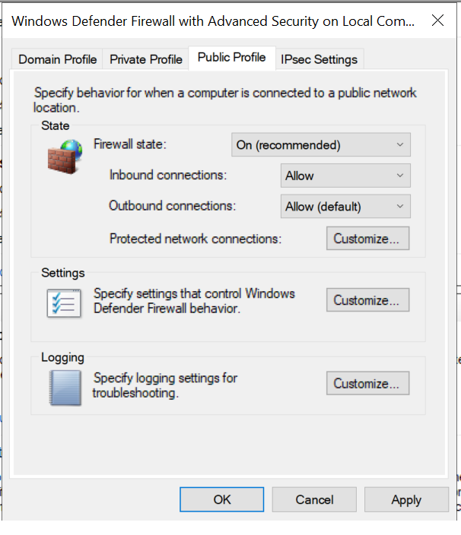

DO NOT FORGET TO TURN OFF PUBLIC INBOUND CONNECTIONS BEFORE TERMINATING THE INSTANCE.

Now download xampp server since the files will be stored locally.

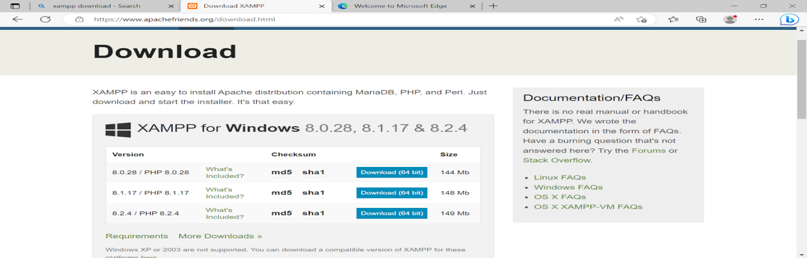

After it has been downloaded, copy the project files from your pc to the ec2 instance.

Into the htdoc folder.

Open xampp, start apache and mysql.

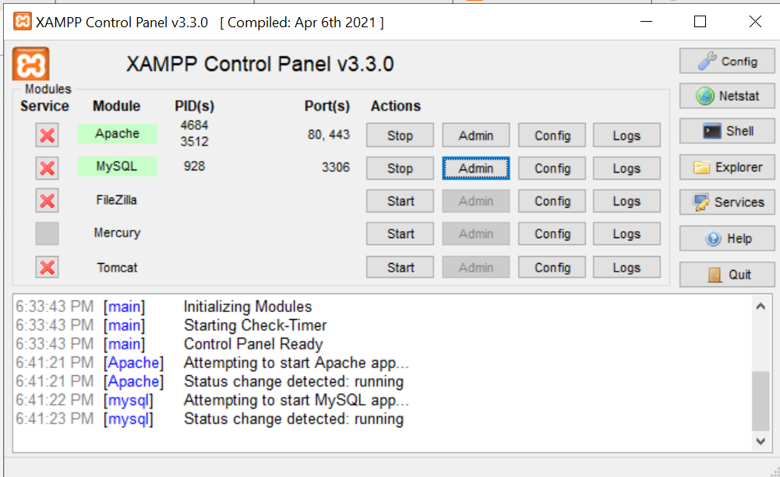

Click on admin of mysql it leads to the phpmyadmin page.

Click on new-> create a database with the same table name.

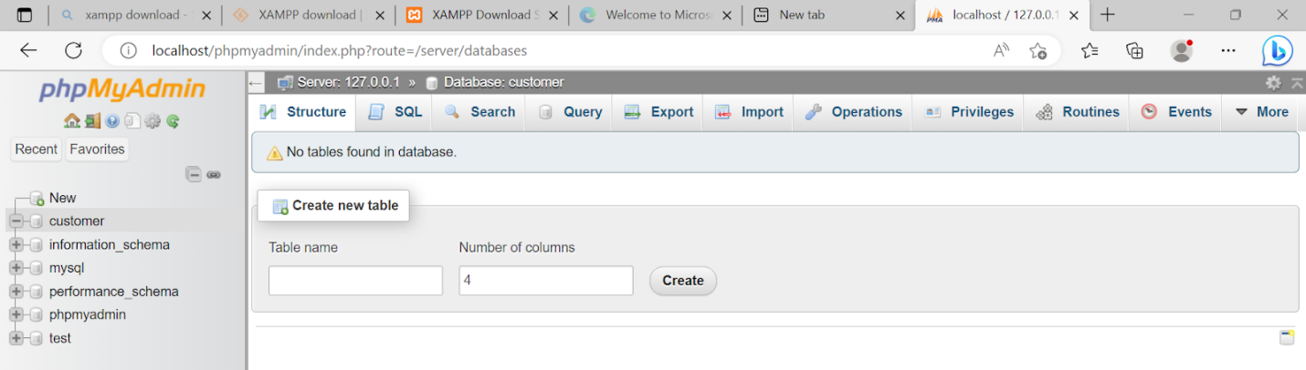

Now import-> browse the sql file we previously created.

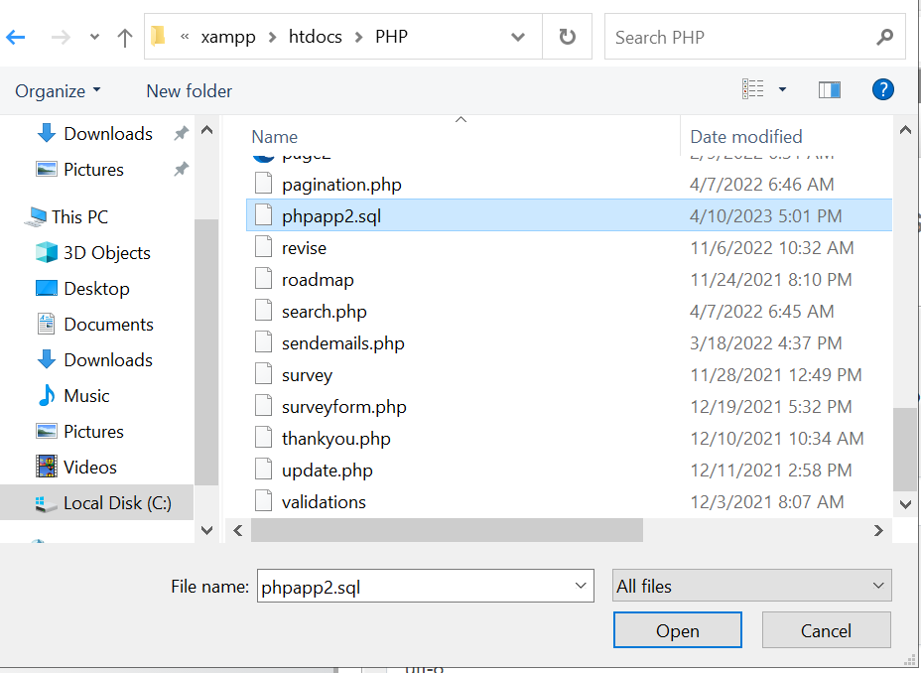

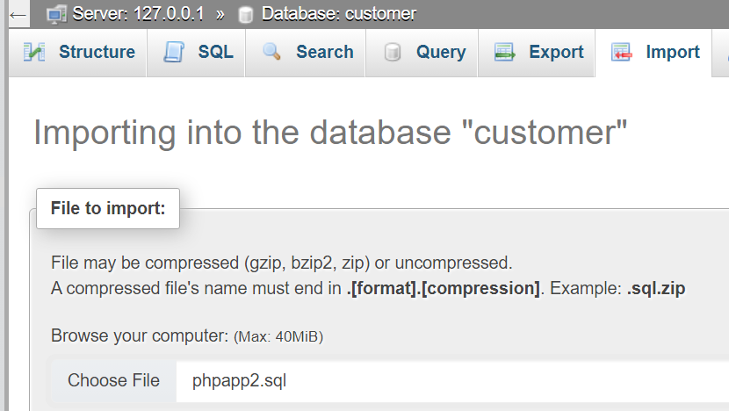

Click on import

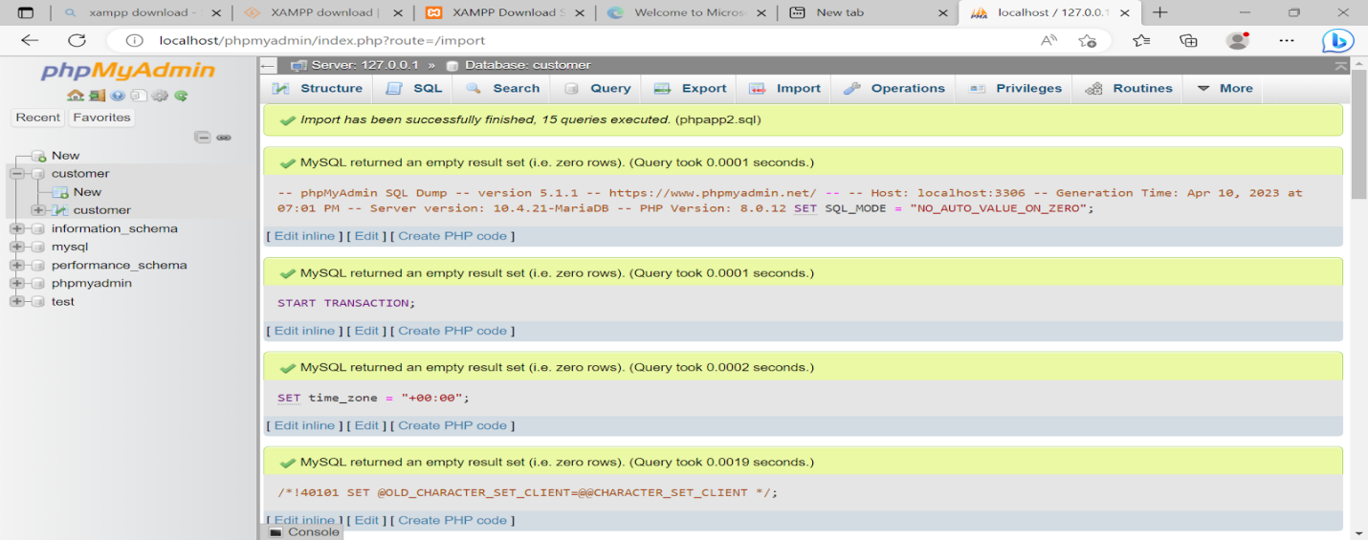

Renaming the database to phpapp2 since that's what was used.

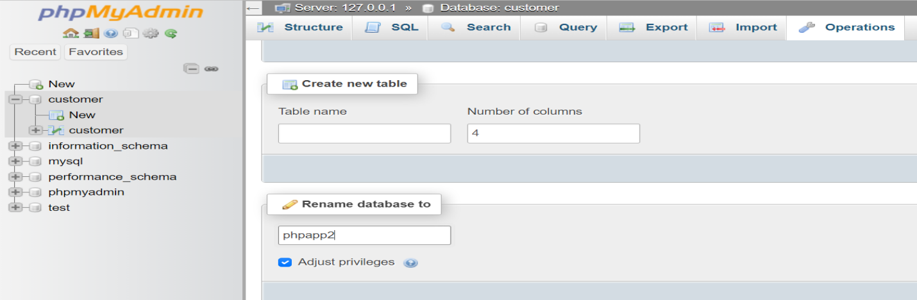

Now if u try to access the website, it works.

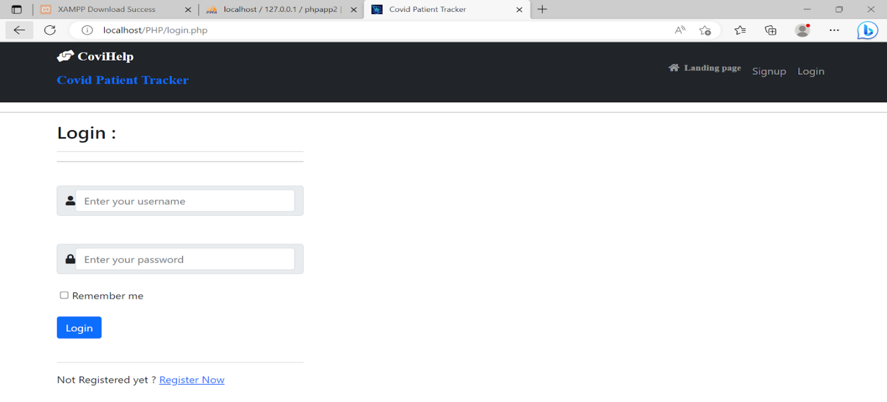

Now search the public ip address that is shown here

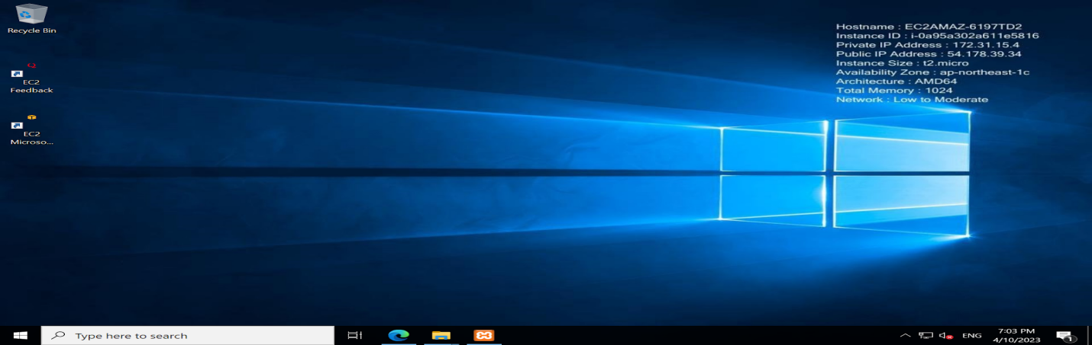

[CPT G_42](http://54.178.39.34/PHP/landingpage.html)

<http://54.178.39.34/PHP/landingpage.html>

That is the ec2 instance’s public ip address/folderPathOfProject

The website has been successfully hosted.

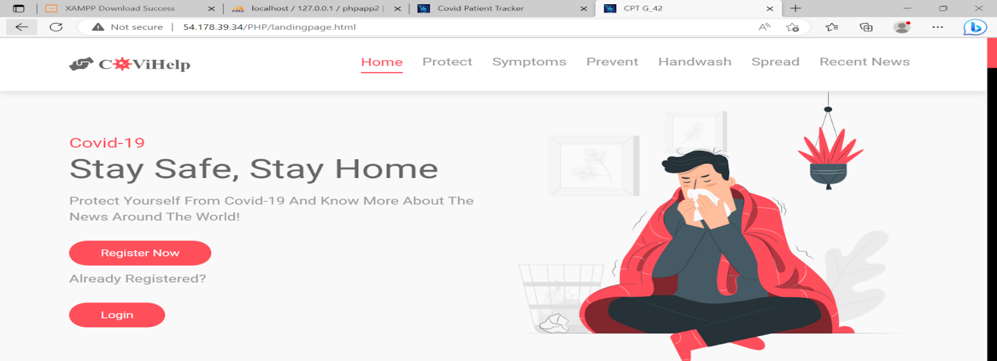

Now minimize the cloud machine, paste the ec2 instance’s public ip address on your machine.

Anyone with that link can now view the website. It has been hosted successfully.

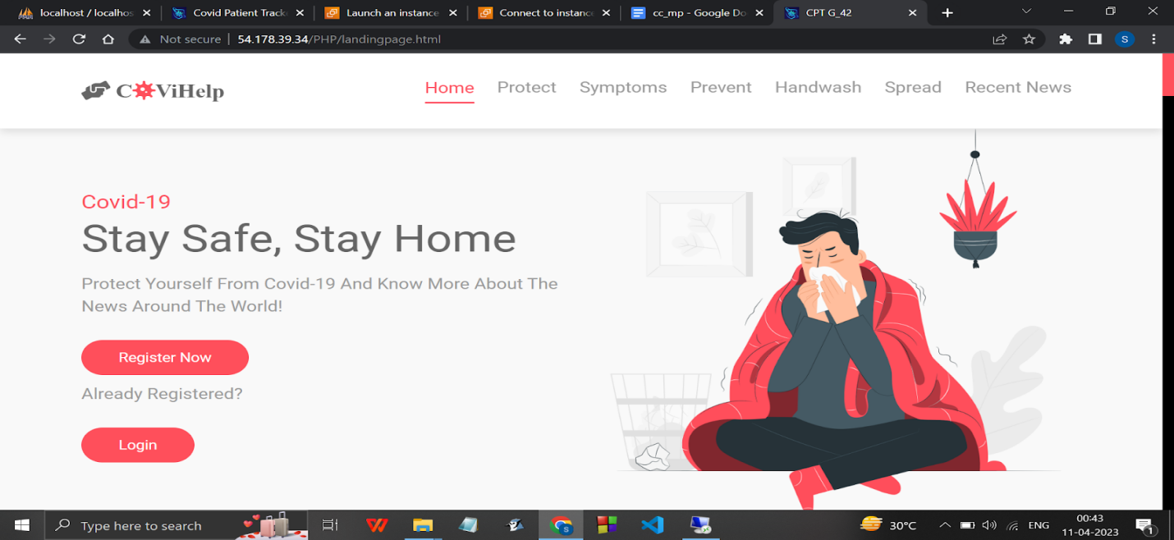

Opening it in phone :

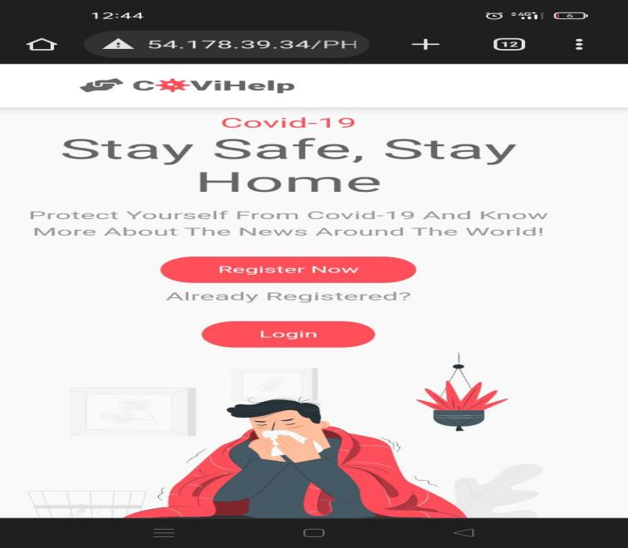

Rds using phpmyadmin

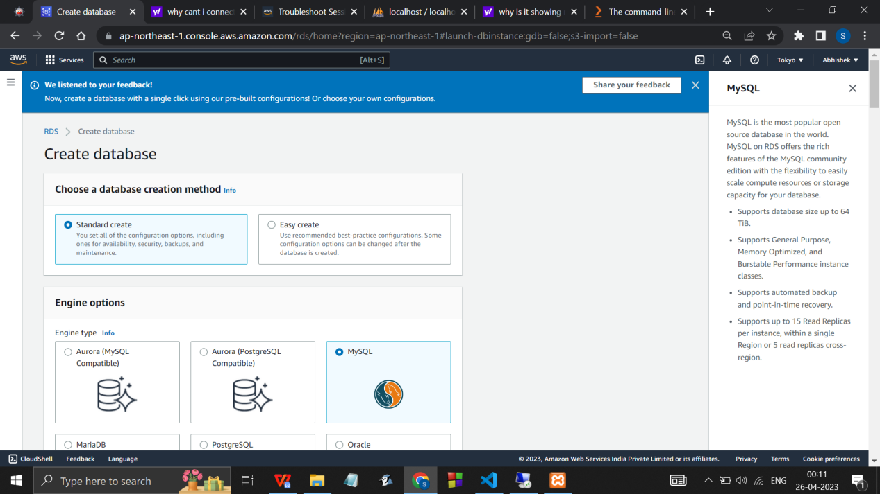

Master pswd: ilikemintchoco

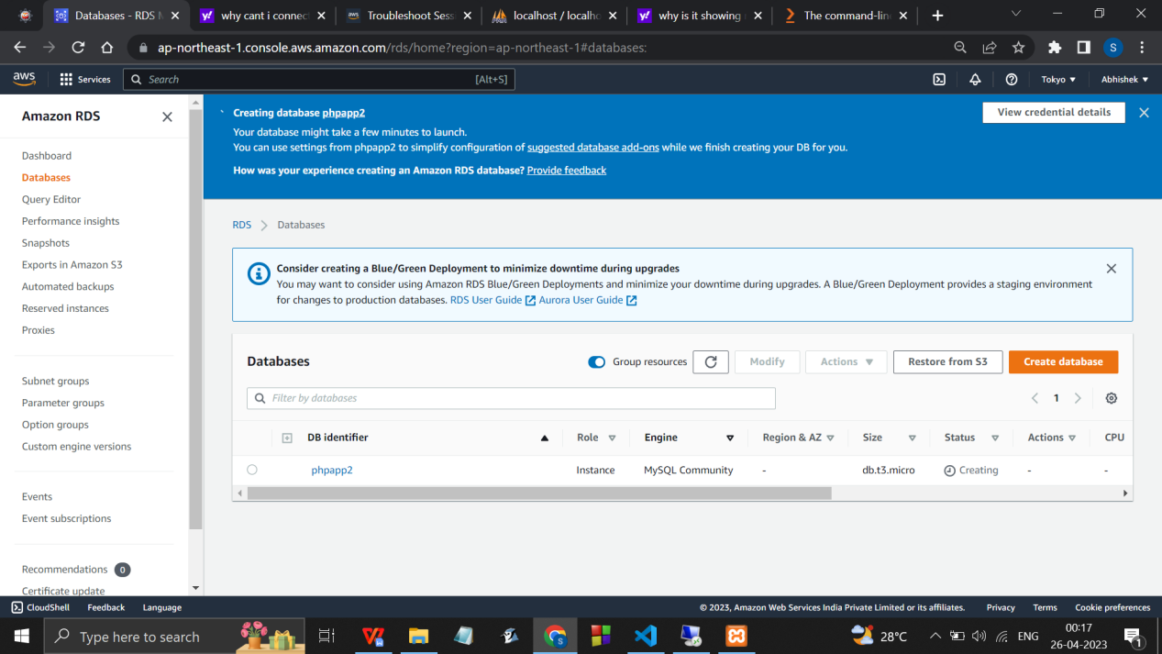

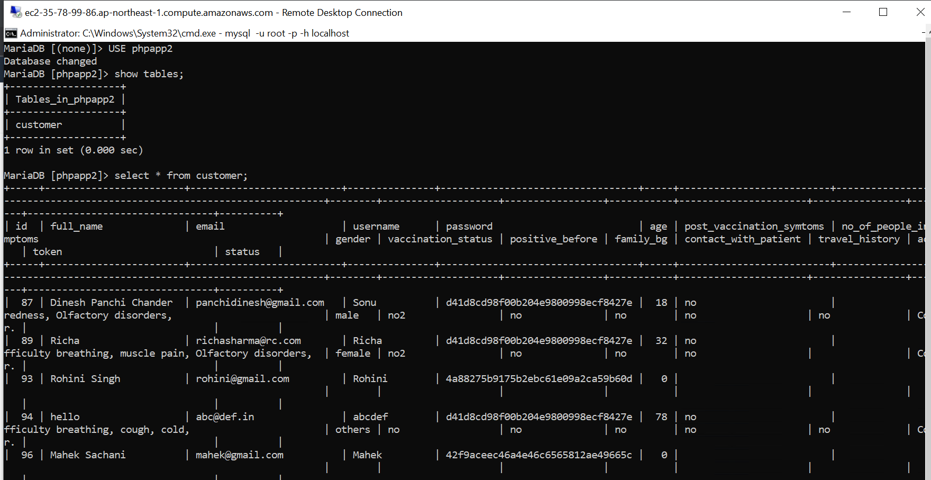

Copy endpoint of newly created database

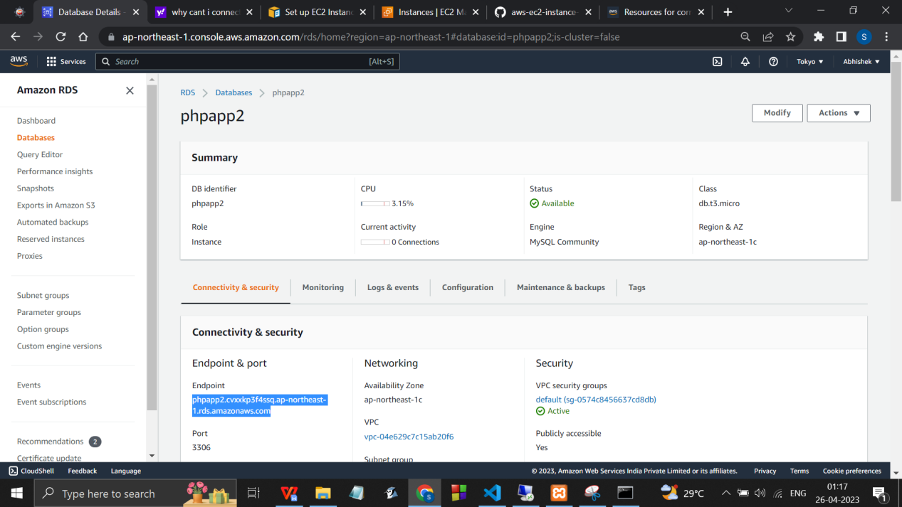

Server: phpapp2.cvxxkp3f4ssq.ap-northeast-1.rds.amazonaws.com



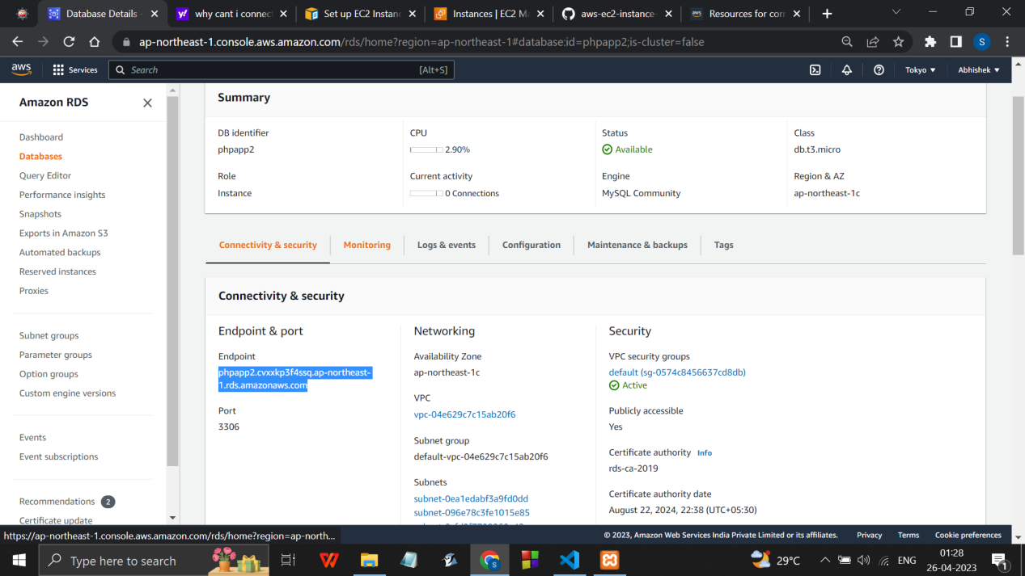

….…………………………………………….

Step 1 : Create a S3 Bucket.

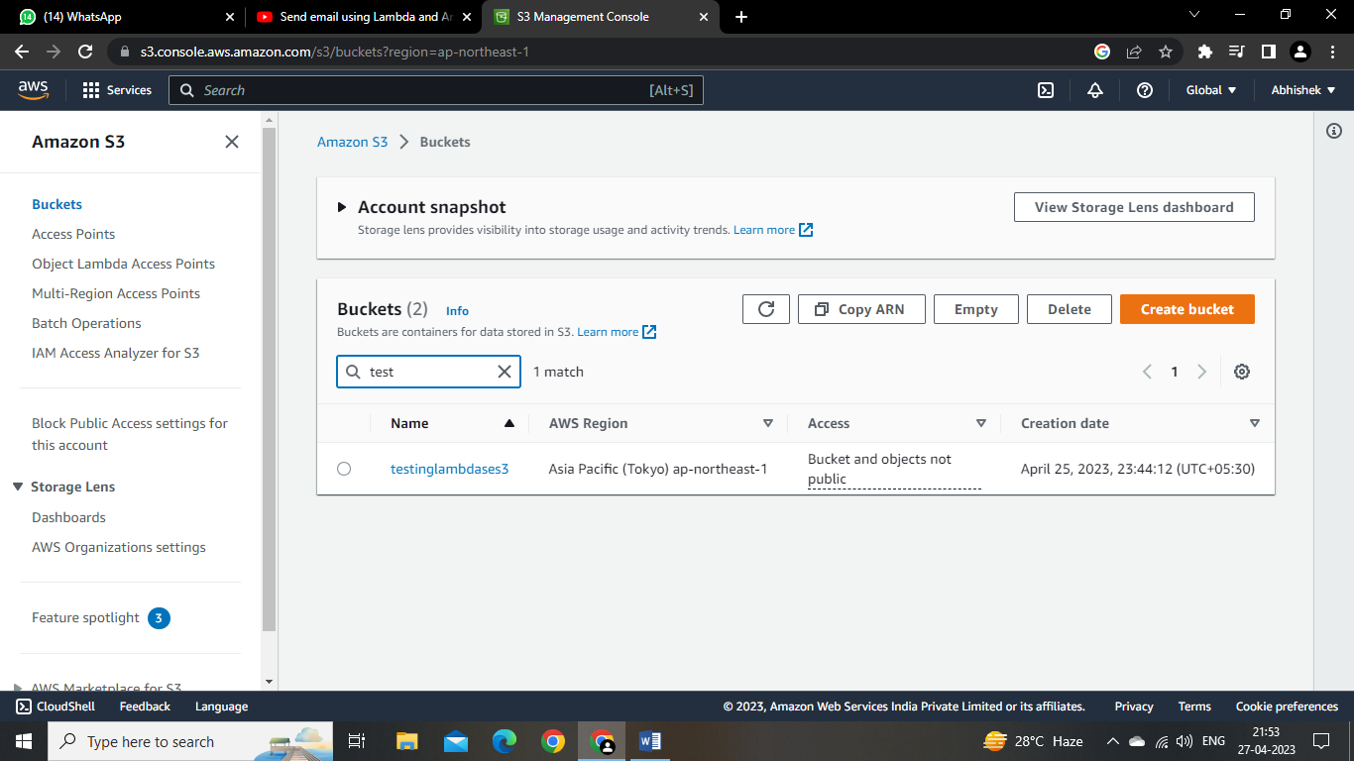

Step 2 : Create an IAM Role and set Permssion policies

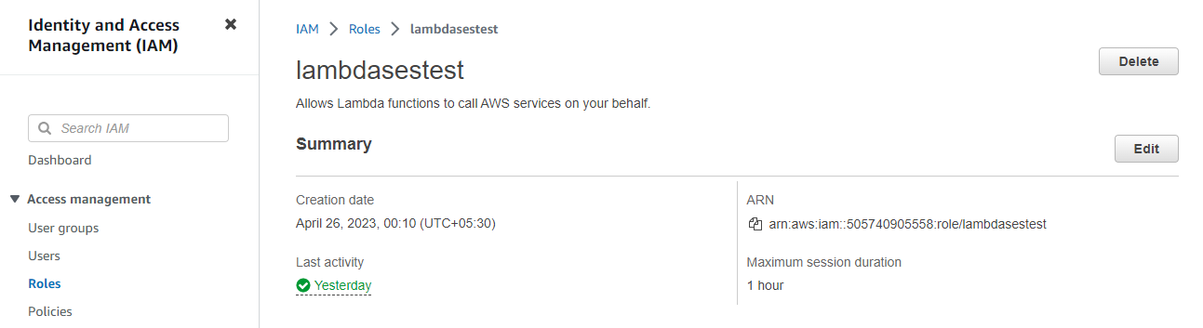

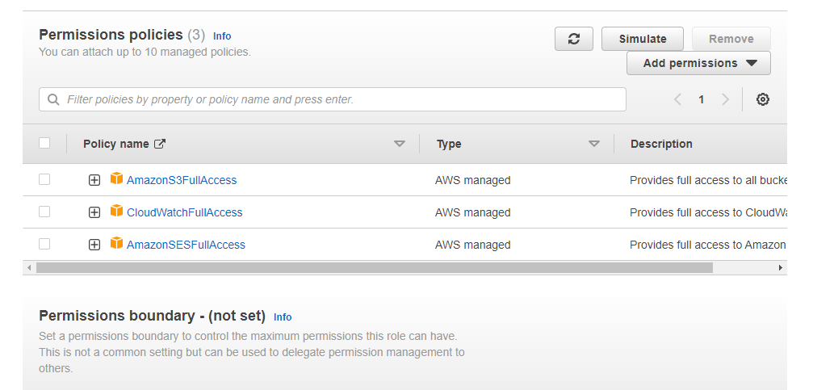

Step 3 : Create Lambda Function

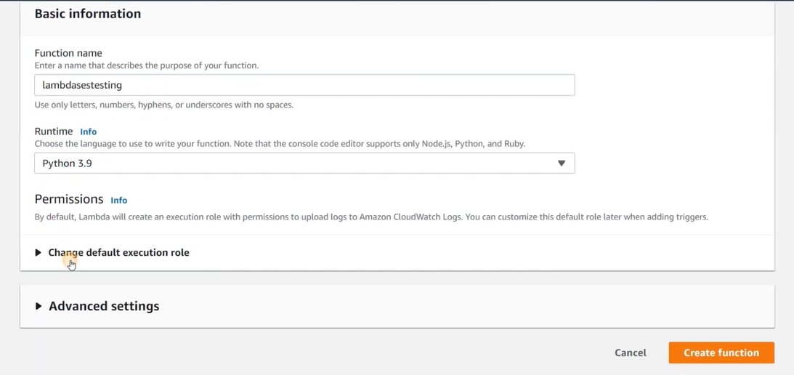

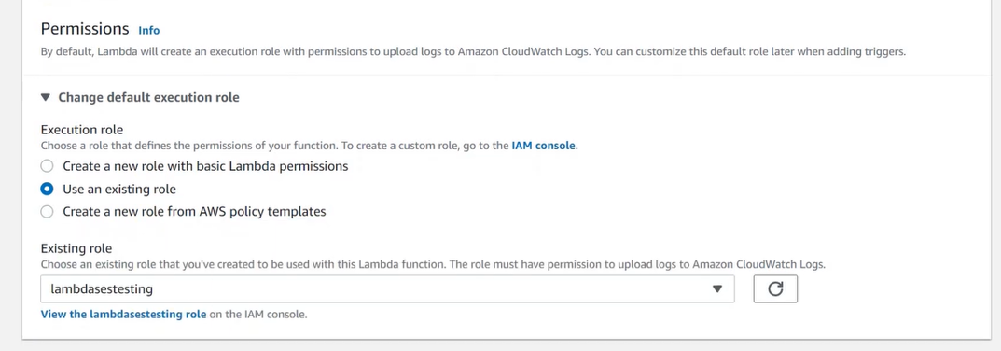

Then, In Lambda function, add Trigger S3

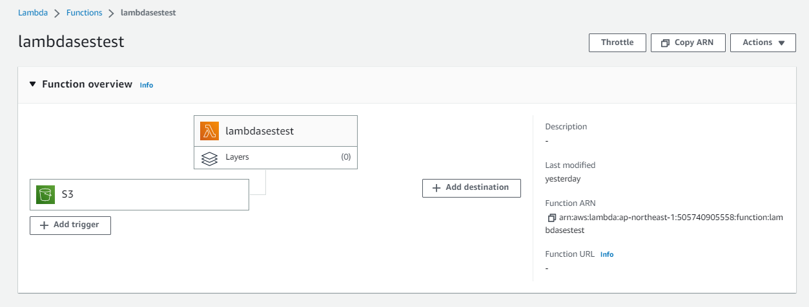

Write the function code according to your need and mention your Email Address in it and Deploy

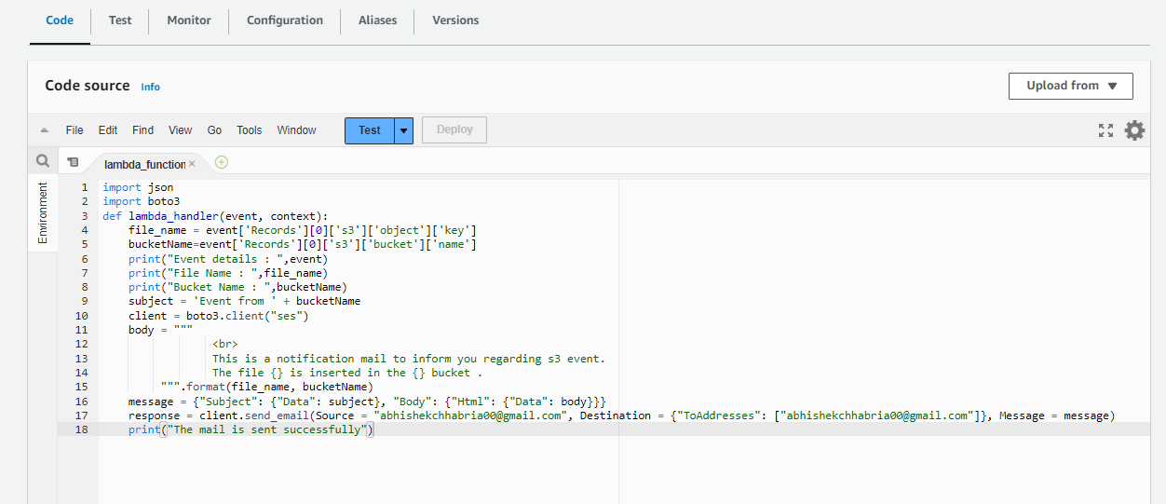

Step 4 : Goto S3 bucket and upload a file

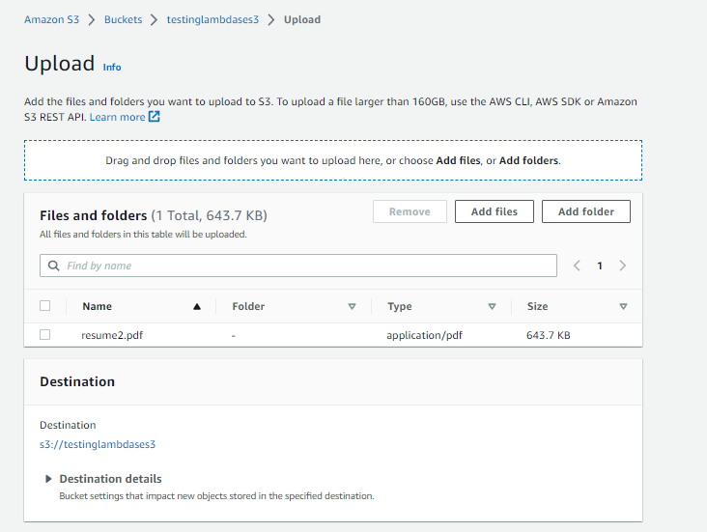

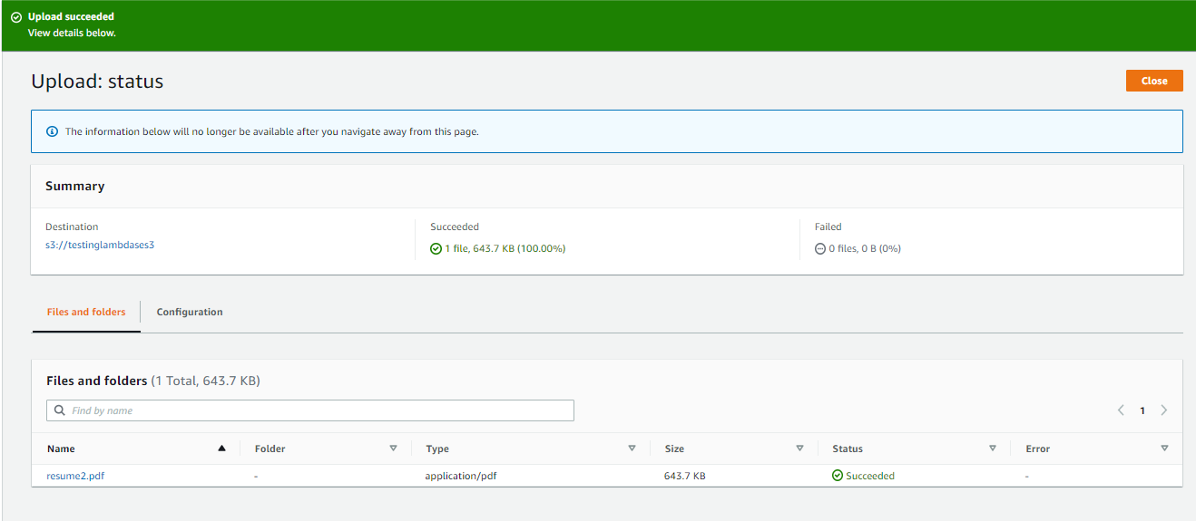

Step 5 : In Lambda function ----> Click Monitor ----> View Logs on CloudWatch

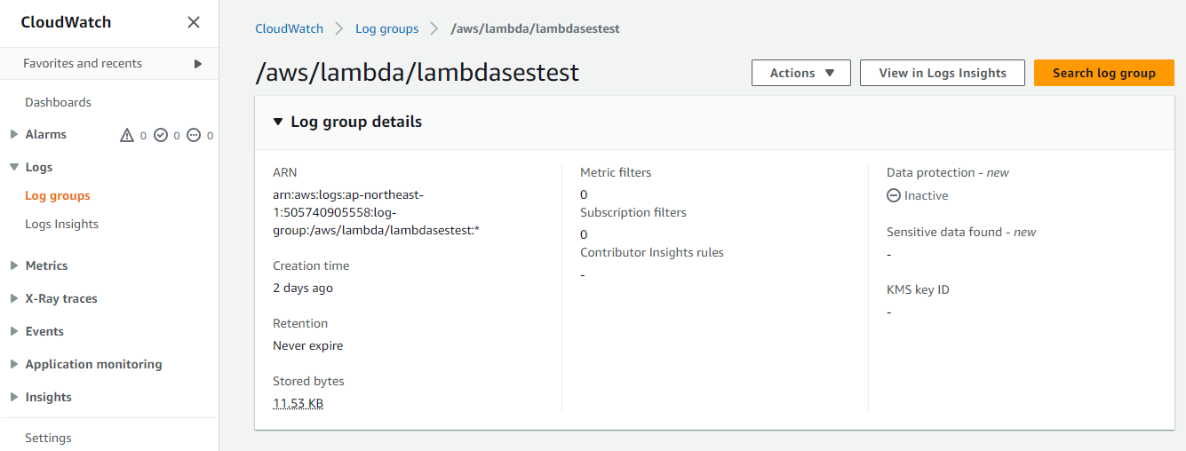

In Log Streams, click on recent event’s link

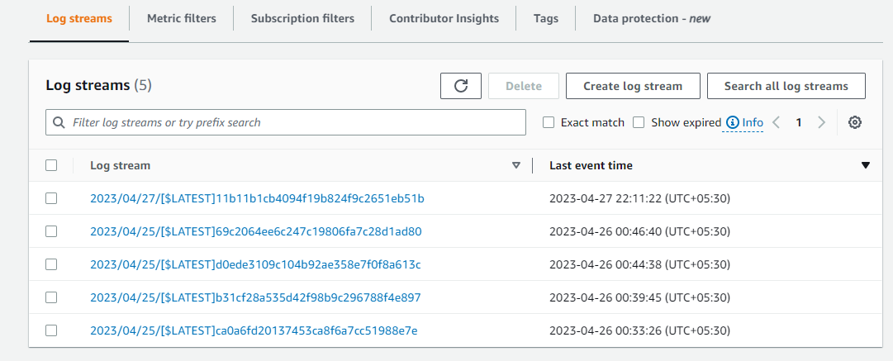

In the messages check if the mail is sent successfully

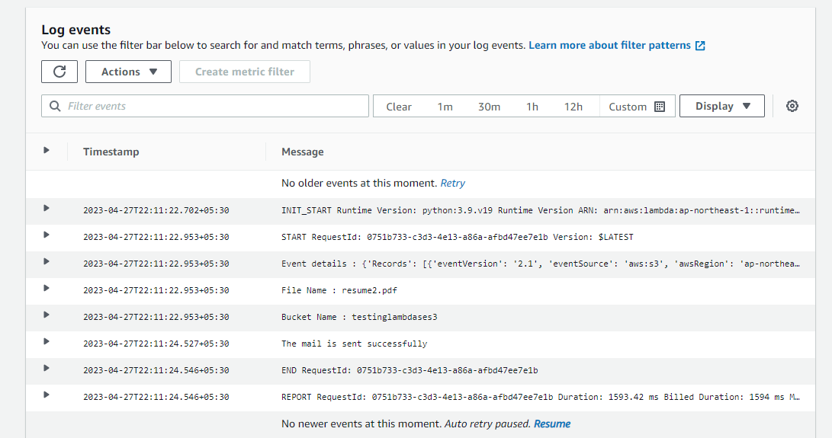

Step 6 : Check if the mail is received successfully

